# Community Contribution (CC) Reviews for Vendors

End users provides linguistic suggestions and change requests in GitHub in the form of Pull Request (PR), which are sent to Moravia for triage and confirmation. As the Moravia target language owner for Cloud and Enterprise Products, the Linguistic input and insight are needed to evaluate the Community feedback. You will be asked to analyze the feedback and the errors reported and follow the below process for reporting to Moravia. However, when the number of PRs is high, the involvement of linguists from the translation teams is required to support the LMs and pre-triage the Pull Request to meet the SLA agreed with Microsoft. Many of the steps below are in common for both LMs and translation teams, which are defined as linguist, unless otherwise specified.

## Overview of the process

This section provides an overview of the overall process, the steps for the linguist are detailed in the following sections.

1. End users enter linguistic suggestions / change requests in GitHub in the form of Pull Request (PR).
2. Moravia engineering team will create the BPI Pull Requests based on the request in GitHub and assign them to the linguist.
3. Linguist receive a notification from BPI from engineering team.
4. Within the deadline provided in the BPI request, linguist confirm if the request from the end user should be accepted or rejected, always referring to:

* MS TermStudio
* MS Style Guide
* [CnE Knowledge Portal](https://portal.moravia.com/prj/msce/LinguisticServices/wiki/_layouts/15/start.aspx#/SitePages/CnE%20Knowledge%20Portal.aspx)

And providing:

* Issue type and taxonomy.
* A clear and detailed linguistic justification for the rejection / acceptance.
* Correct target.
* Spent time for each task.
* Production Teams will assign to vendor and implement approved changes in the file(s) in OddJob.
* Engineering team enters linguist feedback in GitHub.
* Production Teams will invoice time spent for each task.

## Expected throughputs

The linguist is expected to process PRs with the throughputs below:

* Daily: 2-4 PRs a day
* Weekly: 10-20 PRs a week

We will try to send heads-up as early as possible in case of peaks.

# What is GITHUB Pull Request (PR)?

If you are not familiarized about GITHUB, below you will find some background information about it that will help you to gain deeper understanding of this task. GITHUB Pull Request (PR) is a methodology for submitting contribution to source code repository using GITHUB.

### What are you looking for in a Pull Request?

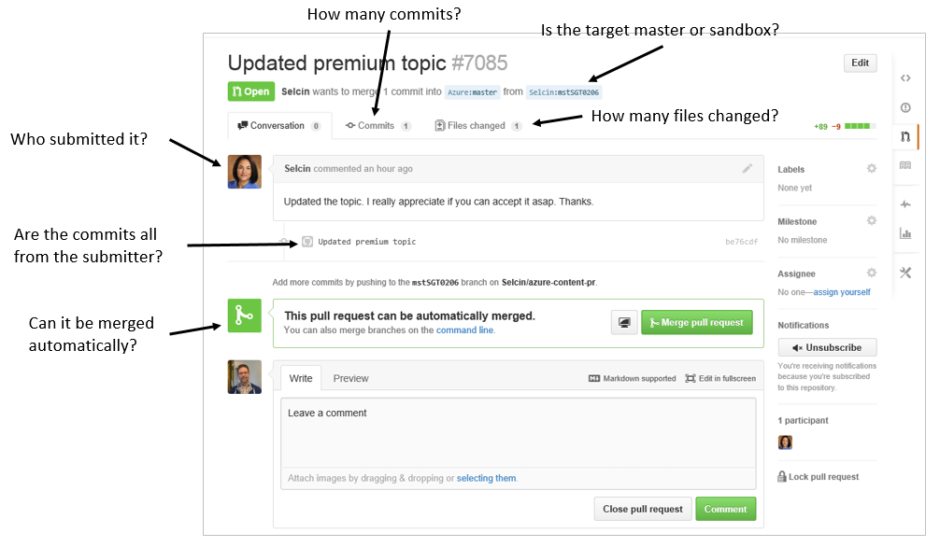

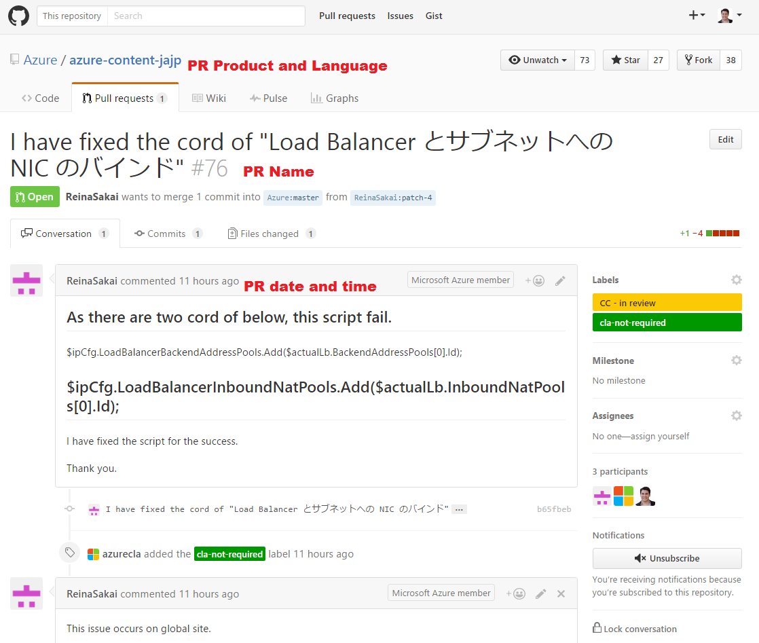

### In the picture below, you can see how suggestions are marked in GitHub web view:

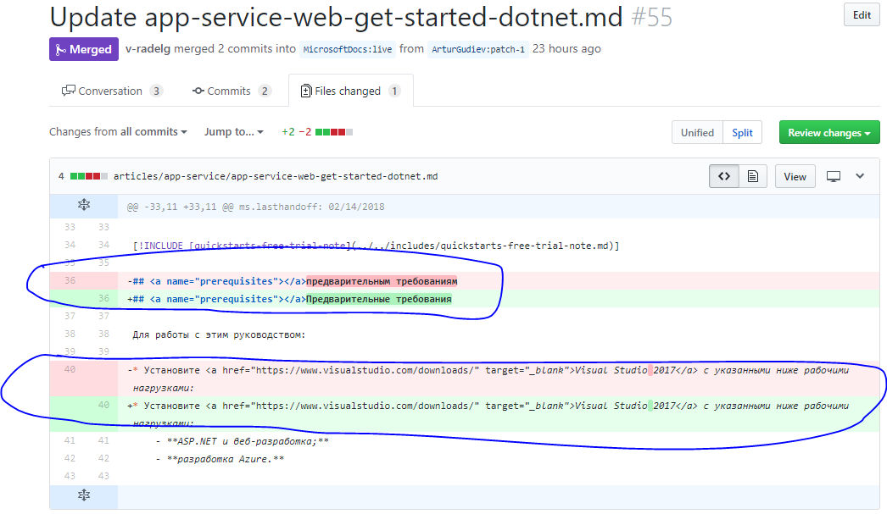

# Handling the Pull Request in BPI

The engineering team create the Pull Request and assign it to the Linguistic through BPI <https://bpi.moravia.com>. The PR request in BPI will contain all the information from the GITHUB PR (PR name, language, Product and PR date) needed for the vendor to triage the request.

**Use your MNET account to log in in BPI.**

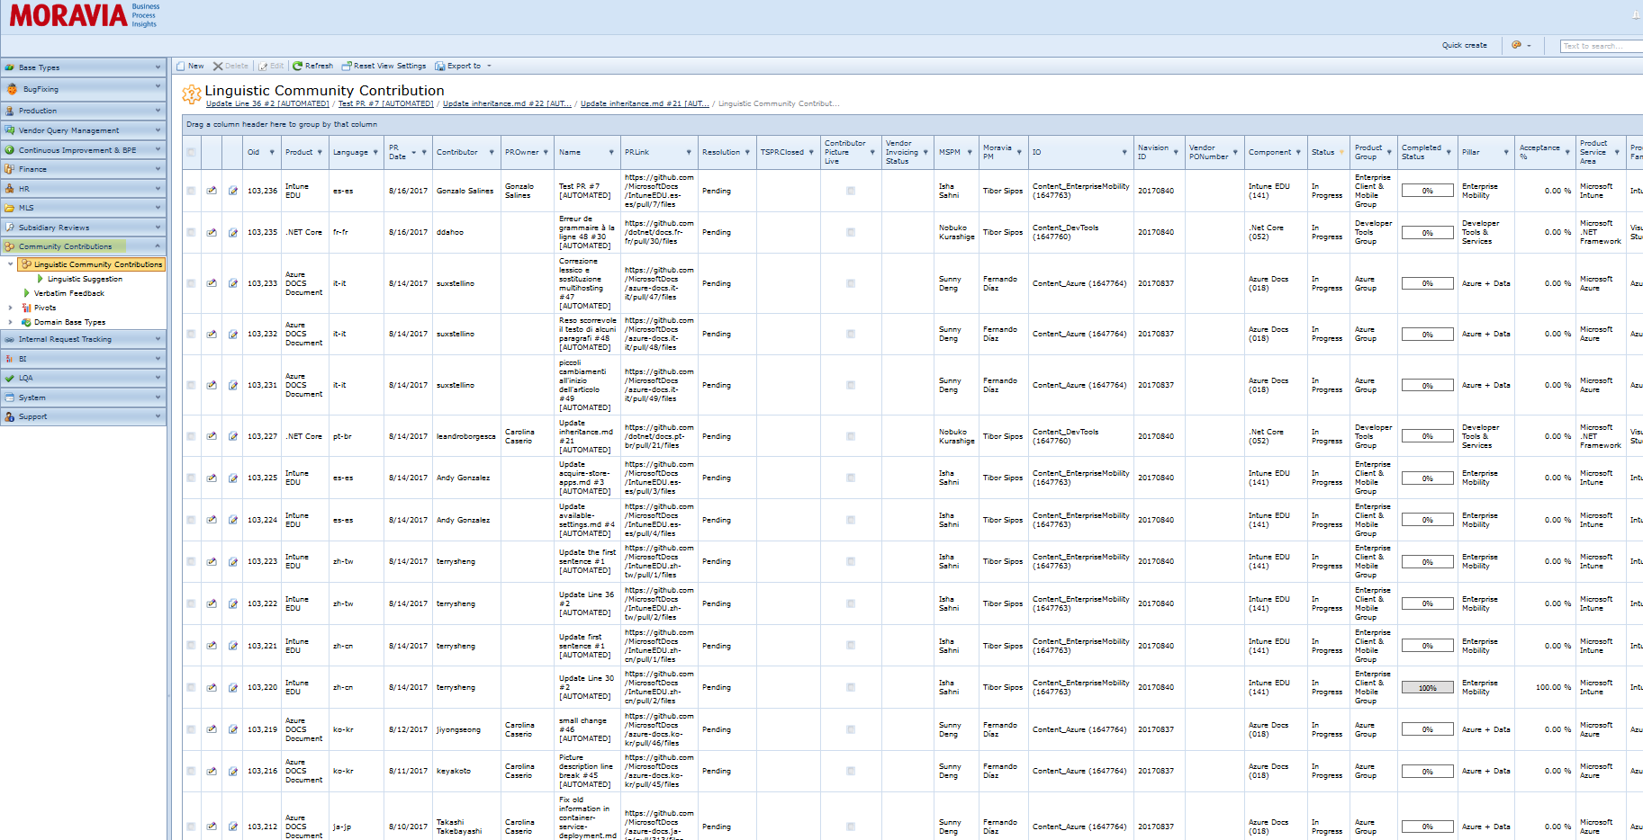

Each GitHub PR can contain several suggestions in one or more than one file. The linguistic receives a notification for each linguistic suggestion, which must be treated separately in BPI. The following steps need to be performed on each Linguistic Suggestion received.

You will receive an email like this one

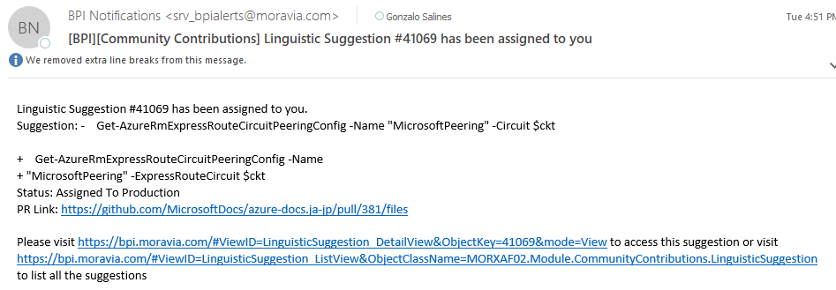

You can click on the second link to open this suggestion on BPI or you can click on the third link to see all the suggestions, then you can filter clicking in the funnel icon by your account name in "Assigned to" and "Assigned to LM" in "Status", as shown in the screenshot below.

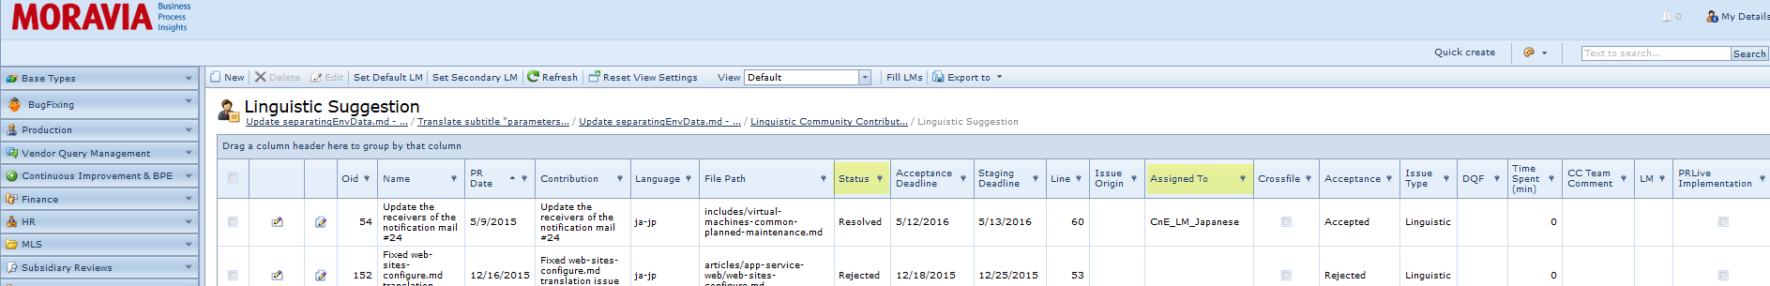

The first link in the e-mail will open the Pull request in GitHub.

Once received the request, click on the link provided in the e-mail and a suggestion window will pop-up as the one below.

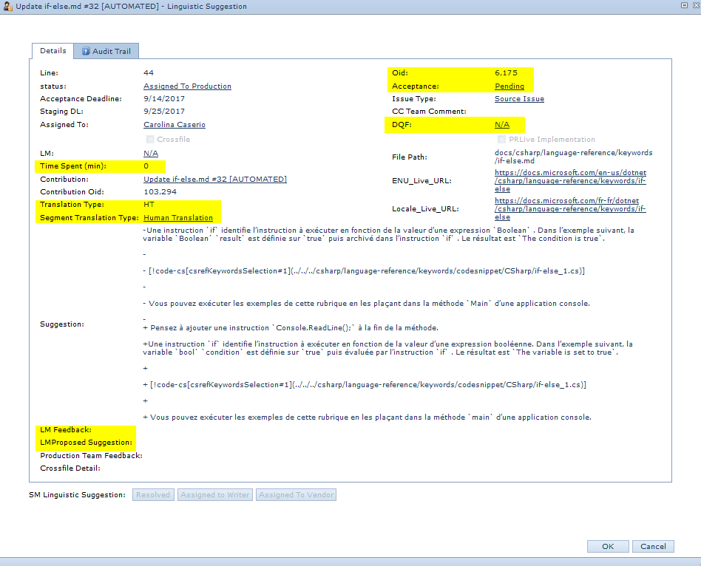

3. To be able to work on the suggestion ticket, you need to click on Edit button in the upper left corner.

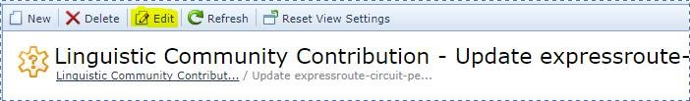

**Note:** To access to the Pull request information, please open them by clicking on the Contribution link.

5. Then fill carefully all the following fields.

• LM feedback: LM feedback on the suggestion.

**IMPORTANT: If the contribution is rejected, please also provide the reasons why in your native language, so we can get back to the contributor.**

• LMProposed Suggestion: If neither the current nor the proposed translation is correct, please add which would be the correct one.

• Acceptance: select "Accepted" or "Rejected" accordingly

• Issue type: select "Linguistic", "Source Issue" or "Technical" accordingly. Most of the time this field will be already set. Only modify it if necessary.

* DQF: **Linguistic Issue Categorization. In case suggestion was accepted You should select corresponding option.**



The Suggestion ticket will contain the following fields that don't need to be updated by the Linguistic, but are important to check.

• Line: file line of the modified suggestion

• Contribution: PR Name

* File path: Filename and the Path in the repository.

• Contribution OId: The ID for the contribution, in case you need to refer to it, to know exactly the amount of suggestions created on that PR.

* CC Team Comment: Any relevant Comment from MOR side which can be useful for you.

• Translation Type: Indicate if file has been Human translated or Machine Translated This is important to know when judging the content.

• Segment translation type: Human translation / Machine translation. Sometime a machine Translation file might have human translated segments recycled from a HT TM.  
**Please see information above about triaging MT bugs.**

* Time Spent(mins): **DO NOT TRACK YOUR TIME HERE. Its reserved ONLY for LMs.**

• Cross-file: Production Teams will check this if necessary.

• **Acceptance deadline: deadline to accept/reject PR.**

• Staging deadline: Production team deadline to stage the file, which will then be published live.

• Status: It will be completed automatically once the Status machine at the bottom is changed

• Assigned to: Correspondent Linguistic account name.

• Suggestion: Correction itself. It shows the current translation in the file and the proposed translation by contributor.

• File Path: File name with dynamic Path from GitHub.

• ENU_Live_URL: English live page for reference.

• Locale_Live_URL: Target live page for reference

• Audit Trail: Shows the whole list of users that interacted with the suggestion.

The Suggestion Ticket also contains the following tabs:

• Description: Brief explanation from the contributor about the change. It could contain useful information.

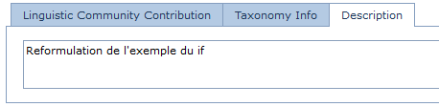

• Taxonomy info: Contains information about the product.

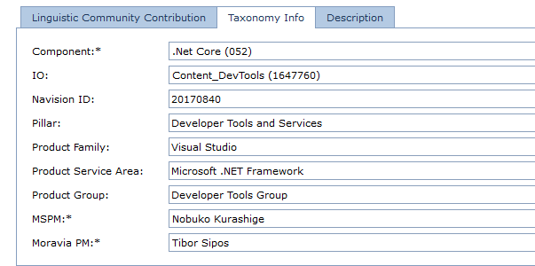

## How to Track your time (For PO purposes)

1. Complete the field with the time to track

cid:image005.png@01D3855D.C4A84090

1. Click on the clock button.   
   cid:image006.png@01D3855D.C4A84090

A window popup will appear to confirm

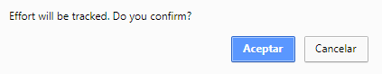

1. The effort track will be showed on the Linguistic Effort tab

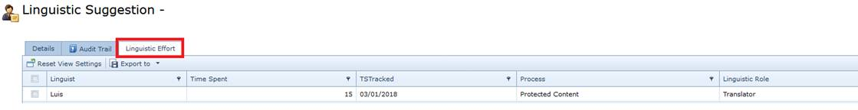

1. Change the Linguistic Suggestion status

cid:image009.png@01D3855D.C4A84090

1. If the status selected is "Feedback Received from Linguistic Vendor", click on Save (or Save and Close)

**IMPORTANT: ALWAYS REMEMBER TO SAVE THE CHANGES, OTHERWISE THEY WILL BE LOST.**

**Note:** Engineering Team assigns the files to the production Teams via BPI, who will apply the changes in Oddjob.

## Triaging the requests

The section below explains the criteria of acceptance of linguistic suggestions.

Important: if the there is a TCR suggestion resulting from the community contribution, it should be immediately reported to Ines (InesMoreno@moravia.com), who will process it. As it is considered Priority 1, since it comes from the subsidiaries, it will be processed in Term Studio in 24 hours. You can send the PR to the CC team for implementation as per normal process outlined above with a comment that a TCR has been created.

## Requests that can be accepted (Translation team only)

1. Mistranslation correction
2. Style correction. For MT string, please check the Linguistic Criteria below.
3. Correction of source string.

## Requests to reject

1. Transcreation requests.
2. Country specific change about feature and its specific environment.
3. If the UI string is unlocalized in content, don't accept the translated UI strings as the feedback.

## Requests to escalate

1. Anything with uncertainty, please send e-mail to the Moravia requestor.
2. If a change might apply to all languages, i.e the EN-US source should be updated, escalate via email to the Moravia requestor.

## Requests that must be escalated to the LM (Translation team only)

1. Terminology change request.
2. New Terminology.
3. Changes that cannot be solved without the LM's feedback.

## Linguistic Criteria of acceptance for community contributions on MT segments

**When you receive a ticket where the segment translation type is MT (Machine Translation), different acceptance criteria apply. Please see below:**

### Items to check:

* Typos, spelling, grammatical and punctuation issues.
* Anything offensive and illegal.
* Obvious omissions.
* Branding names.
* Over-localized.
* Not localized.

### Items NOT to check:

* Terminology
* Style/syntax as long as it's readable.

# Summary:

1. Click on the BPI link in the e-mail notification
2. Check the suggestion from the contributor.
3. Select the acceptance option. (accepted/Rejected)
4. Select corresponding DQF. (If applies)
5. Add your feedback or rejection reason. (If applies)
6. Propose a better suggestion (If applies)
7. Select the corresponding Status.
   1. *“Feedback Received from Linguistic Vendor”* in case you were able to handle the ticket
   2. *“Assigned to LM”* in case you have linguistic doubts and need escalation.
8. Track the time you spent on the ticket.

In case you have technical Issues contact via e-mail: [Gonzalos@moravia.com](mailto:Gonzalos@moravia.com) and add in CC [EmanuelR@moravia.com](mailto:EmanuelR@moravia.com)   
For any other doubts contact via e-mail: AlejandraO@moravia.com  and Add in CC [Gonzalos@moravia.com](mailto:Gonzalos@moravia.com); [DOrue@moravia.com](mailto:DOrue@moravia.com)